Sofía Aragón Rabadán
6° B

Types of Webs

Web 1.0:

It is the first stage of development of the internet. They are web pages that are static that means that they aren’t interactive; like a blog. They are just simple places for looking information. Companies develop software applications that users can download, but they can't see how the application changes.

Web 2.0:
It is the second stage of development of the internet. It is the change of static web pages to more dynamic ones.
Examples: My Space, Wikipedia, etc. These are interactive webpages, and you can edit them.
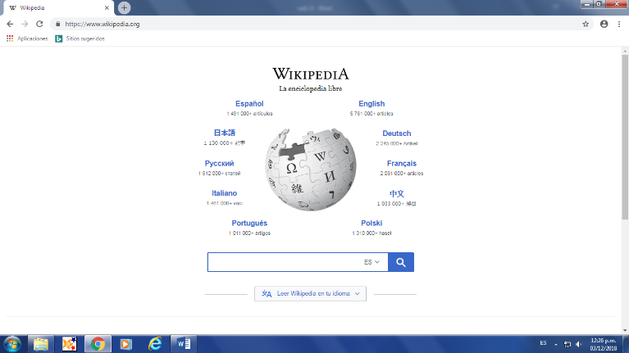

Web 3.0:
It is the third stage of development of the internet. It is going to change the way people interact with web pages, because it would be easier to search for things.
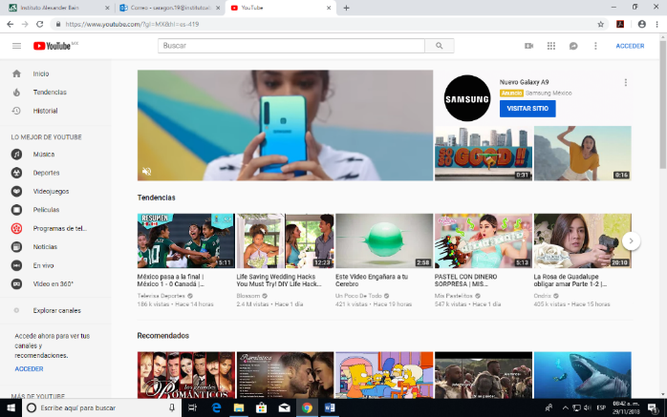
Examples: Netflix, You Tube, etc. This is because this type of webs can remember what you liked, saw, etc.

Web 4.0
This new type of web provides us many advantages. The web 4.0 is the most advanced type of web. This can tell you what is happening in live moment. Also, you can manage things from your phone, or computer; like: making a reservation, going shopping, knowing if there´s some accident, etc. This new web, promises us many new changes in our lives.
Examples: Waze, because it can tell you if there was an accident, if a street is blocked, if there’s some police, what is the best route to take to go somewhere, etc.
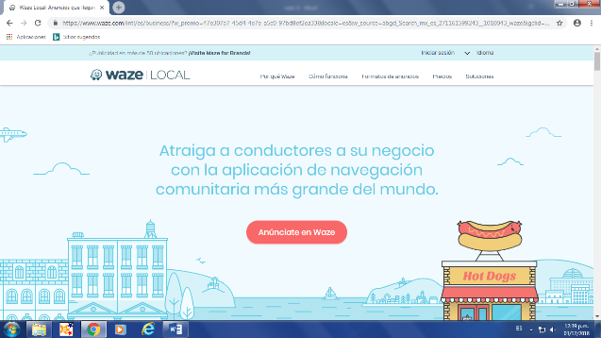

Techopedia, https://www.techopedia.com/definition/4923/web-30

